[**DIGITAL SIGNAL & IMAGE PROCESSING LAB**](https://github.com/Amey-Thakur/DIGITAL-SIGNAL-AND-IMAGE-PROCESSING-AND-DIGITAL-SIGNAL-AND-IMAGE-PROCESSING-LAB)

[**EXPERIMENT - 1**](https://github.com/Amey-Thakur/DIGITAL-SIGNAL-AND-IMAGE-PROCESSING-LAB)

**PART B**

(PART B: TO BE COMPLETED BY STUDENTS)

***(Students must submit the soft copy as per the following segments within two hours of the practical. The soft copy must be uploaded on the Blackboard or emailed to the concerned lab in charge faculties at the end of the practical in case there is no Blackboard access available)***

| **Roll No. 50** | **Name: AMEY THAKUR** |
| --- | --- |
| **Class: COMPS-BE-B-50** | **Batch: B3** |
| **Date of Experiment: 23/07/2021** | **Date of Submission: 28/07/2021** |
| **Grade :** |  |

**A.1 Aim:**

[To study sampling and reconstruction of the signal.](https://github.com/Amey-Thakur/DIGITAL-SIGNAL-AND-IMAGE-PROCESSING-AND-DIGITAL-SIGNAL-AND-IMAGE-PROCESSING-LAB)

**B.1 Snapshot of Sampled Signal:**

**(add a snapshot of output)**

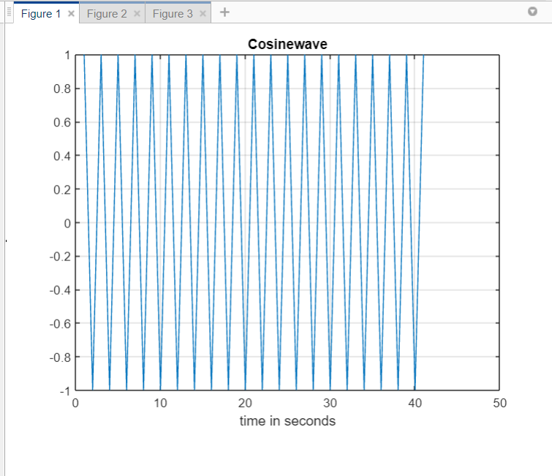

**Figure 1: Cosinewave**

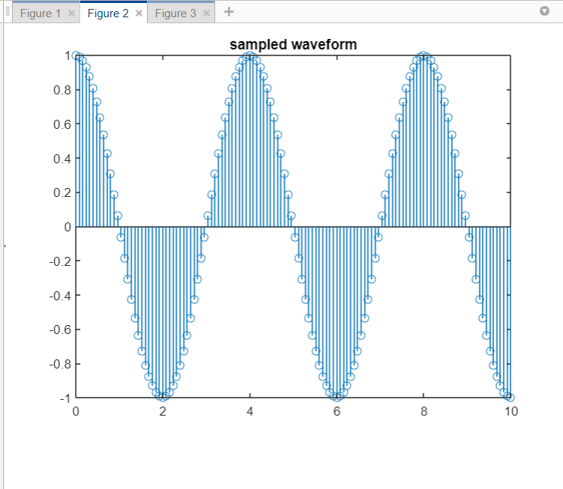

**Figure 2: Sampled Waveform**

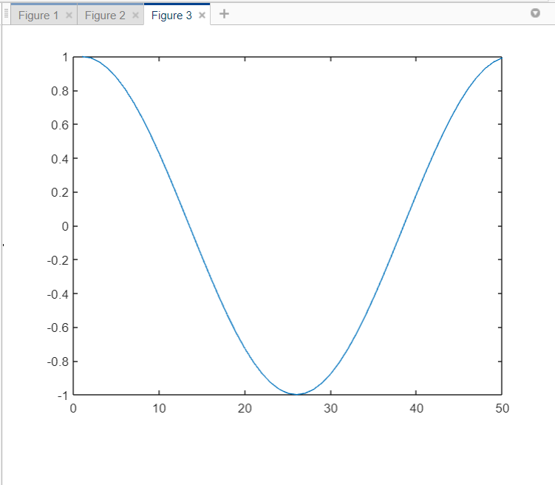

**Figure 3**

**B.2 Source code:**

**(Add source code)**

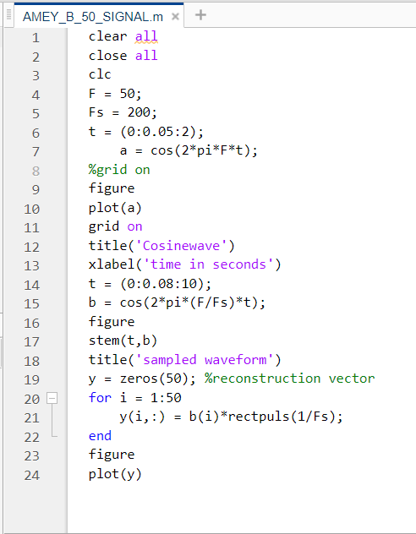

**B.3 Question of Curiosity:**

**(Write appropriate answers in your own word.)**

1. Differentiate between continuous-time signals and discrete-time signals.

Ans:

Continuous-time signal:

* In a signal with time as an independent variable if the signal is defined Continuously far any value of independent variable time(t), then the signal is called continuous-time signal.

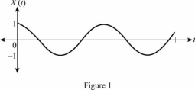

Discrete-time signal:

* In a signal, if time has an independent variable, if the signal is defined only for discrete instances of independent variable time, then the signal is called a discrete-time signal.

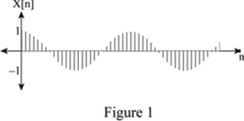

1. What do you mean by sampling?

Ans:

In pulse modulation and digital modulation systems, the signal to be transmitted must be in discrete-time form. If the message signal is coming from a digital source then it is in the proper form for digital communication to be processed. But that is not always the case. Message can be analogue in nature. In such a case it has to be first converted into a discrete-time signal. Thus “sampling” is the process of converting the continuous-time signal into a discrete-time signal.

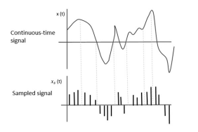

1. What do you mean by quantization?

Ans:

The digitization of analogue signals involves the rounding off of the values which are approximately equal to the analogue values. The method of sampling chooses a few points on the analogue signal and then these points are joined to round off the value to a near stabilized value. Such a process is called Quantization.

**B.4 Conclusion:**

**(Write an appropriate conclusion.)**

As a result, the ideas of continuous and discrete-time signals have been successfully applied and comprehended.